Project 2: JOGL

Documentation

Esther Ho

CMSC 405

Professor Korrapati

Due: 11/4/2018

**Project 2 Documentation**

**My 3D Shapes:**

**-aquamarine color crystal**

**-emerald color crystal**

**-topaz color cube crystal**

**-sapphire color triclinic crystal**

**-amethyst color hexagonal crystal**

**-garnet color trigonal crystal**

**Possible Transformations (user can press buttons to transform objects all together):**

* The user can use various keys to perform transformations:

* -Translation: W, A, S, D keys

* -Rotation: up, down, left, right arrow keys

* -Scaling: +, -

* -to reset: HOME or SPACE button

Test Plan

**NOTE – Screenshots are below the test matrix:**

|  |  |  |
| --- | --- | --- |
| **What is Being Tested** | **Expected Output** | **Output** |
| Proper display of shapes | Display the objects | Objects are displayed properly |
| Press Other Buttons (Negative test case) | Pop up error message when buttons other than specified transformation buttons are pressed. User should be able to keep pressing buttons (the program should not quit) | Error message pops up with message: “invalid key pressed”  Note: seems to lag a little bit. Program is not stopped and can continue pressing other buttons. |
| Left Arrow | Rotate y-axis -20 | y-axis rotated -20 |
| Right Arrow | Rotate y-axis +20 | y-axis rotated +20 |
| Up Arrow | Rotate x-axis +20 | x-axis rotated +20 |
| Down Arrow | Rotate x-axis -20 | x-axis rotated -20 |
| “+” / “=” key | Increase the scale of all axis by 0.2 | All axis increased by 0.2 |
| “_” / “-“ key | Decrease the scale of all axis by 0.2 | All axis decreased by 0.2 |
| W key | Translate along y-axis by +0.2 | Objects move along y-axis by +0.2 |
| S Key | Translate along y-axis by -0.2 | Objects move along y-axis by -0.2 |
| A Key | Translate along x-axis by +0.2 | Objects move along x-axis by +0.2 |
| D Key | Translate along x-axis by -0.2 | Objects move along x-axis by -0.2 |
| “HOME” or SPACE | Reset the view back to the default | Objects are reset back to original view |

Testing Screenshots:

Original State:

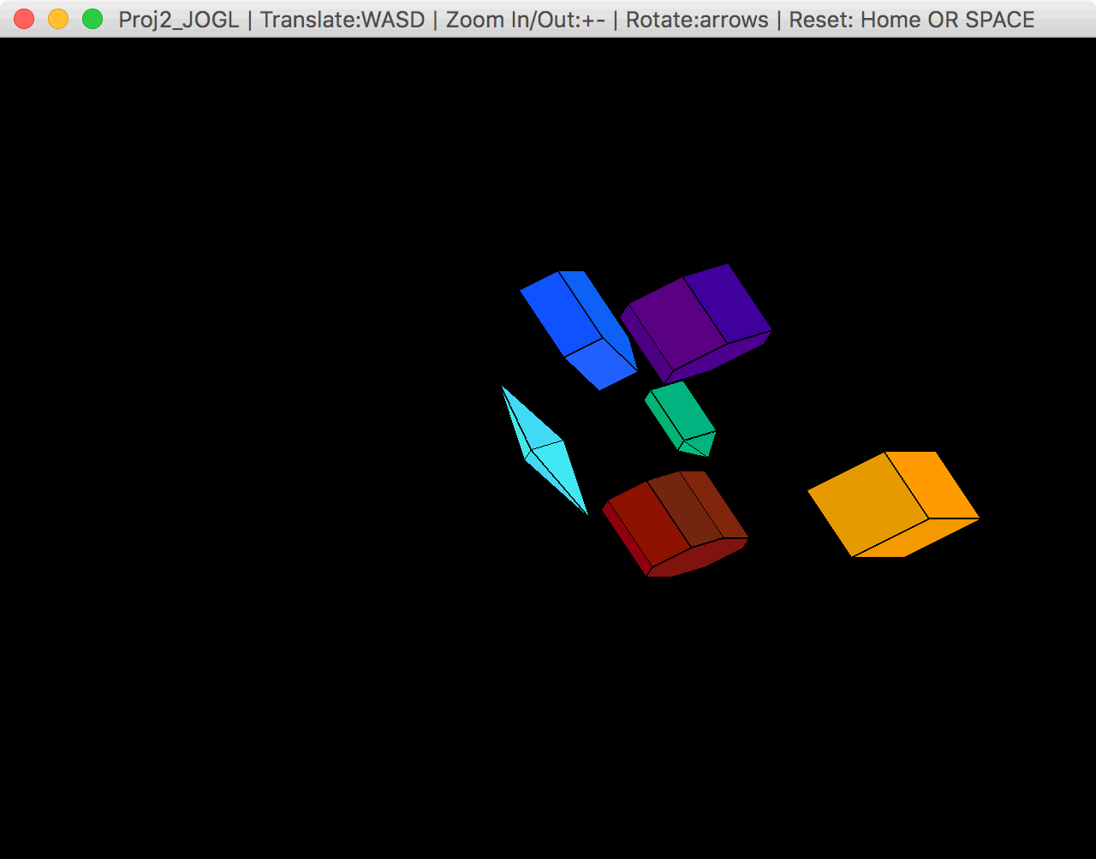

Error:

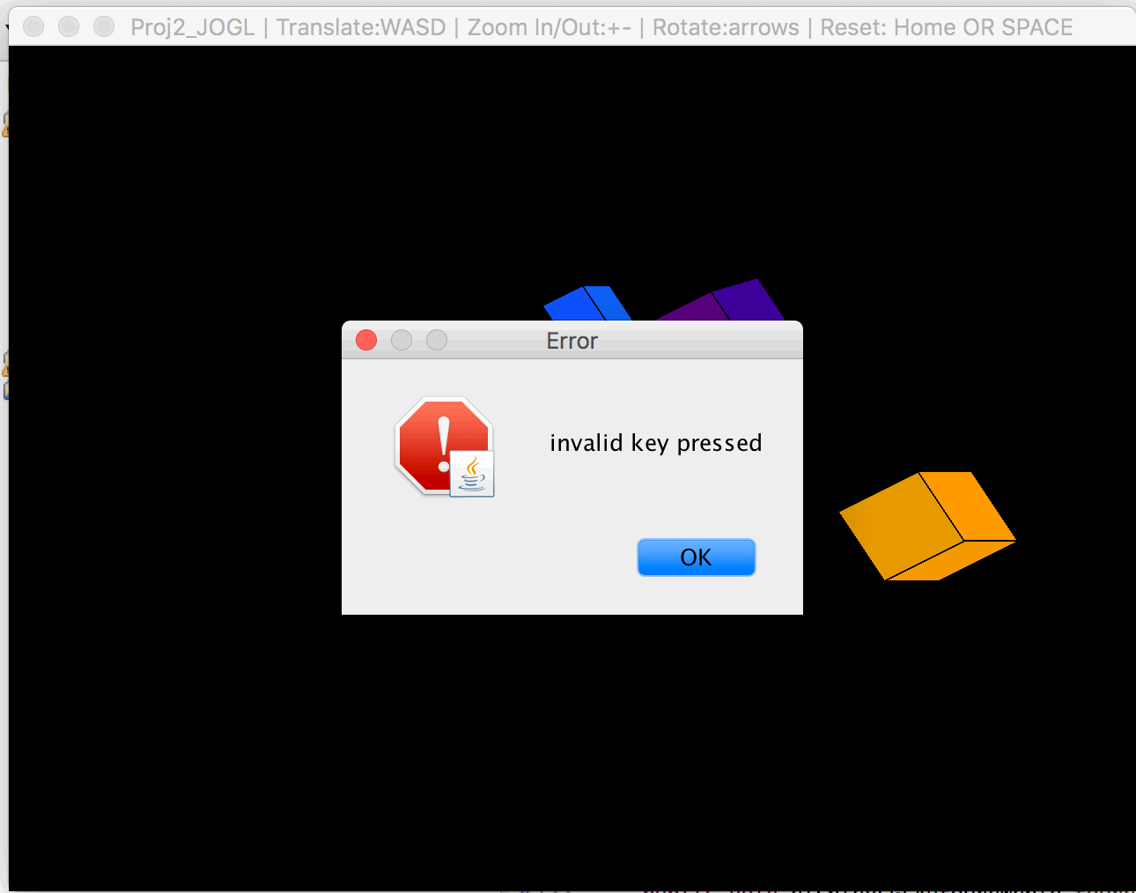

**NOTE: All Transformations are from “home” view. Transformations are not done sequentially.**

“Up” button x2, that rotates the x-axis +20 each time:

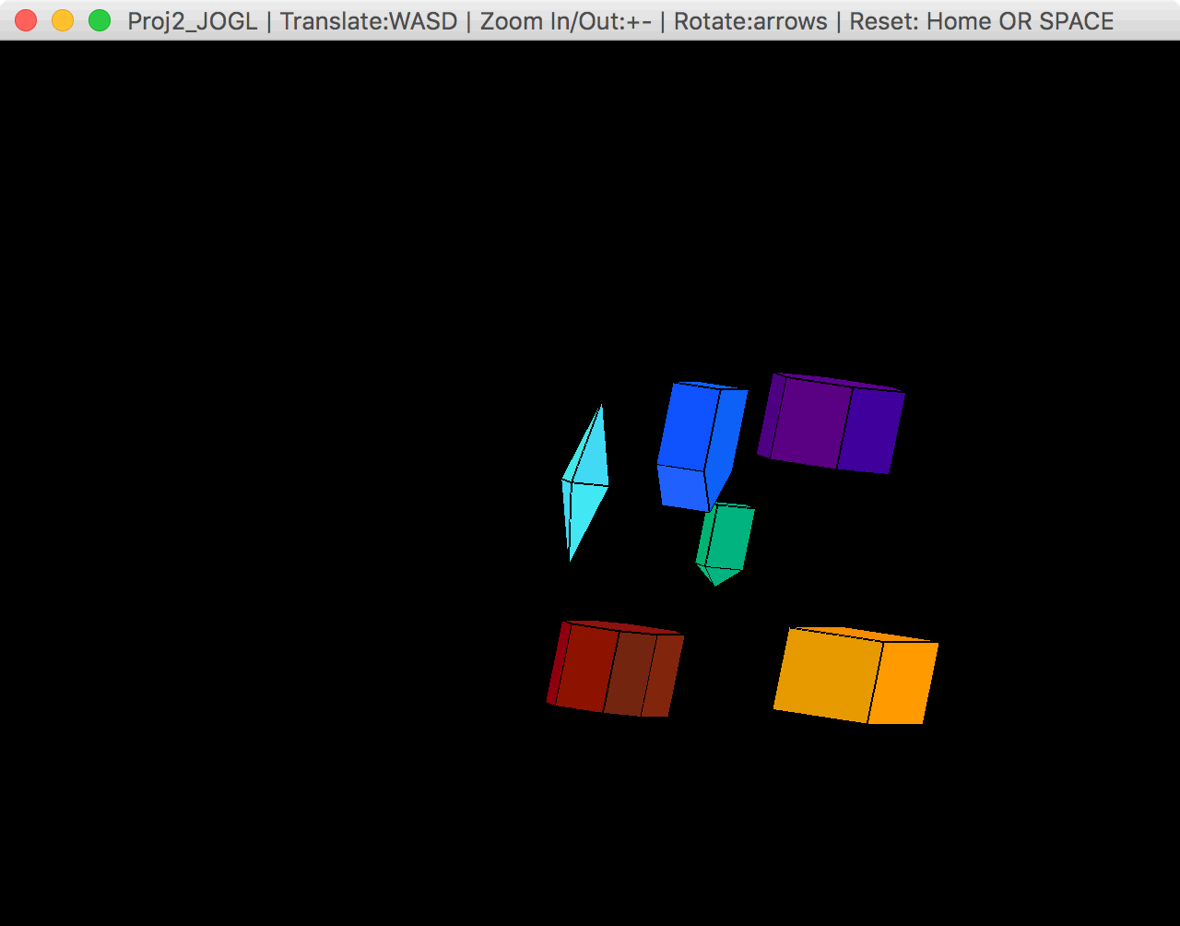

“Down” button x2 that rotates the x-axis -20 each time:

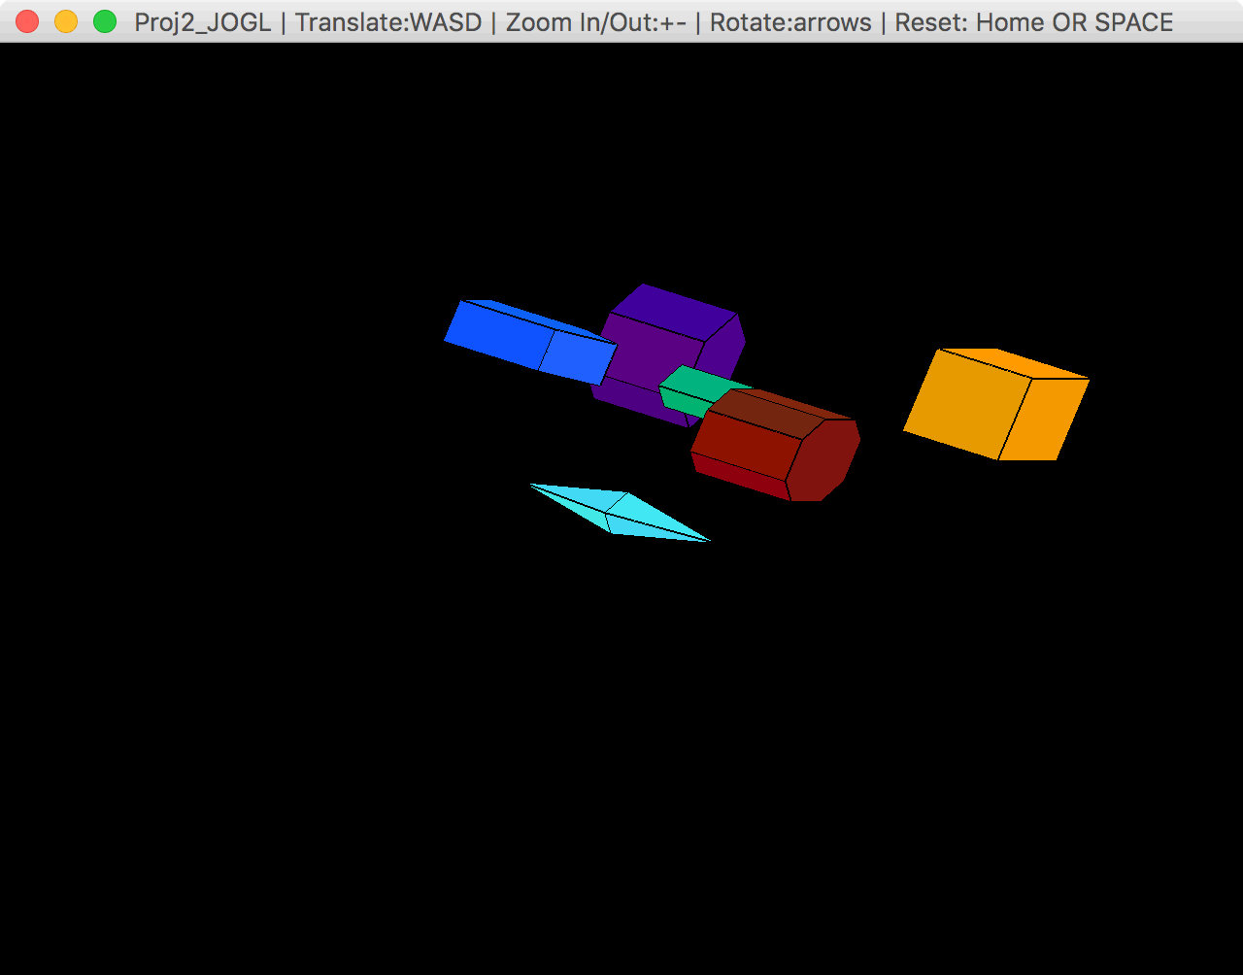

“Left” button x2 that rotates the y-axis -20 each time:

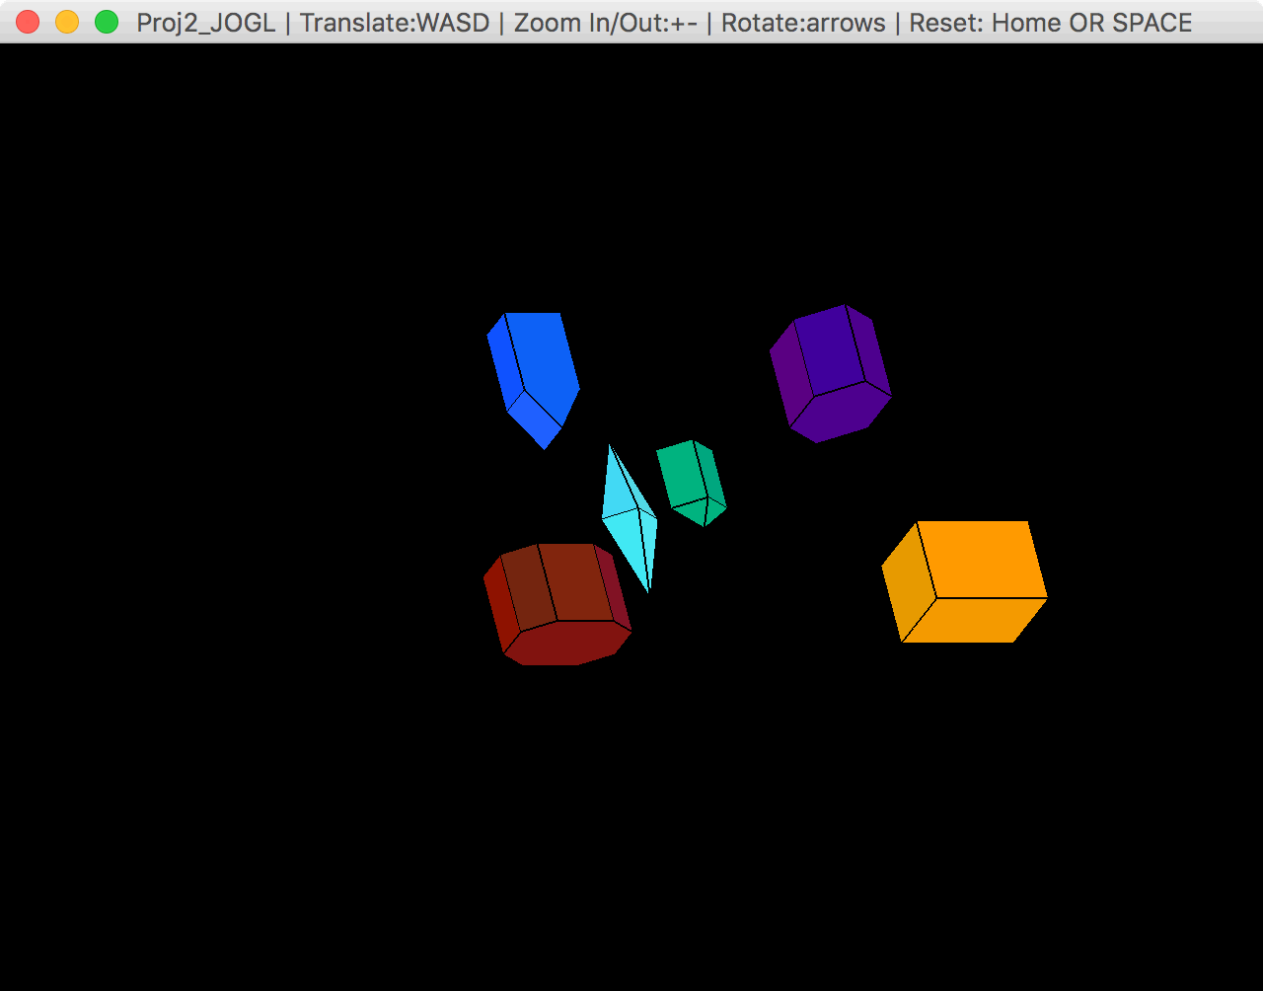

“Right” button x2 that rotates the y-axis +20 each time:

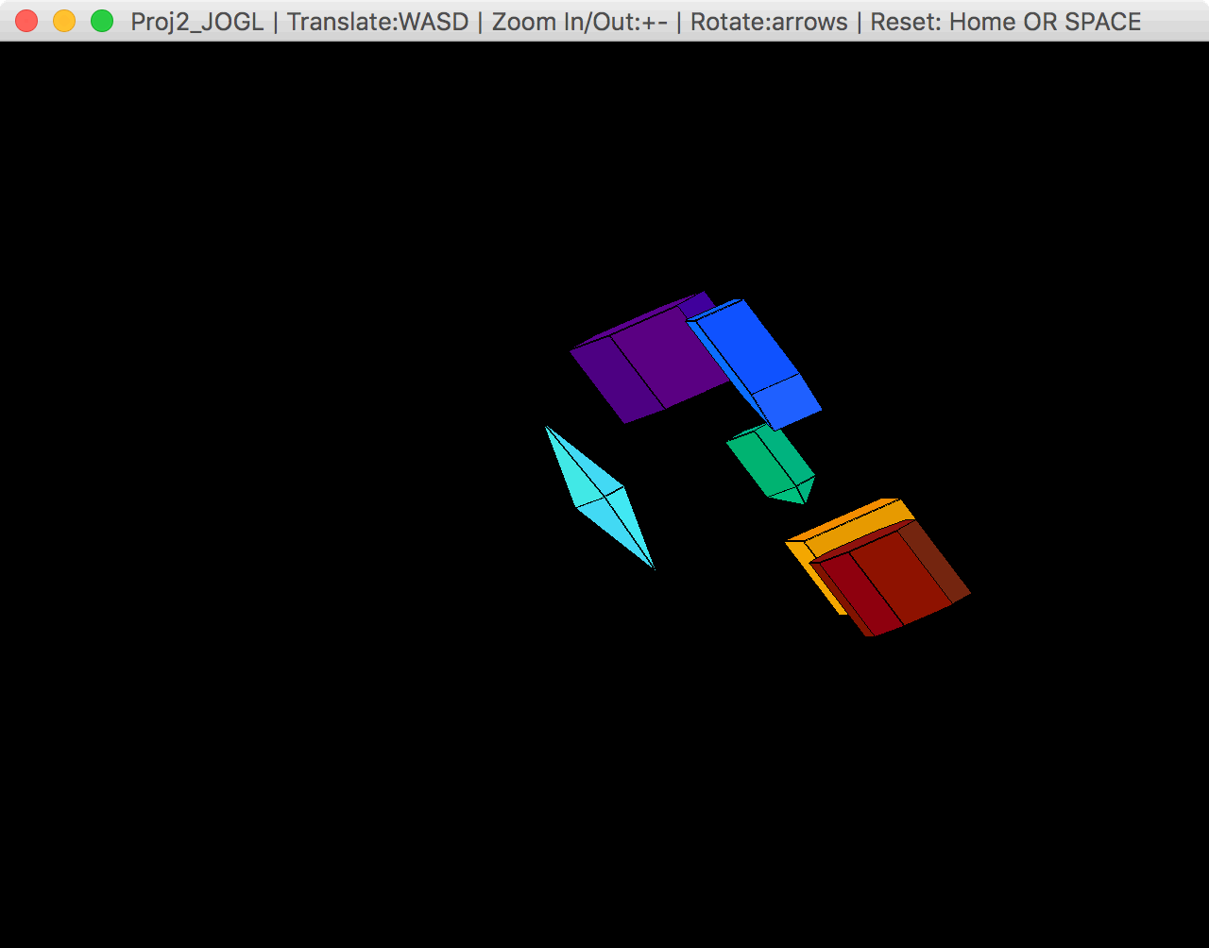

“Plus” button x2 that increases the scale +0.2 each time:

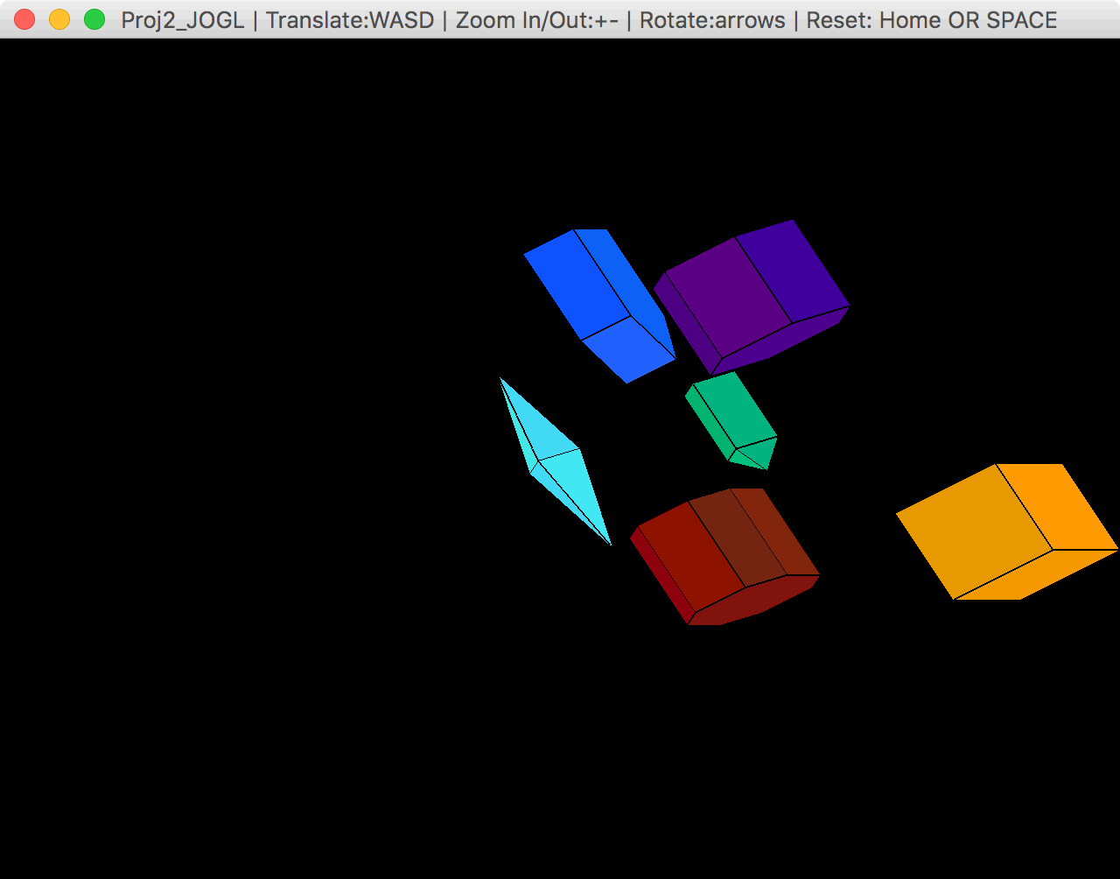

“Minus” button x2 that decreases the scale -0.2 each time:

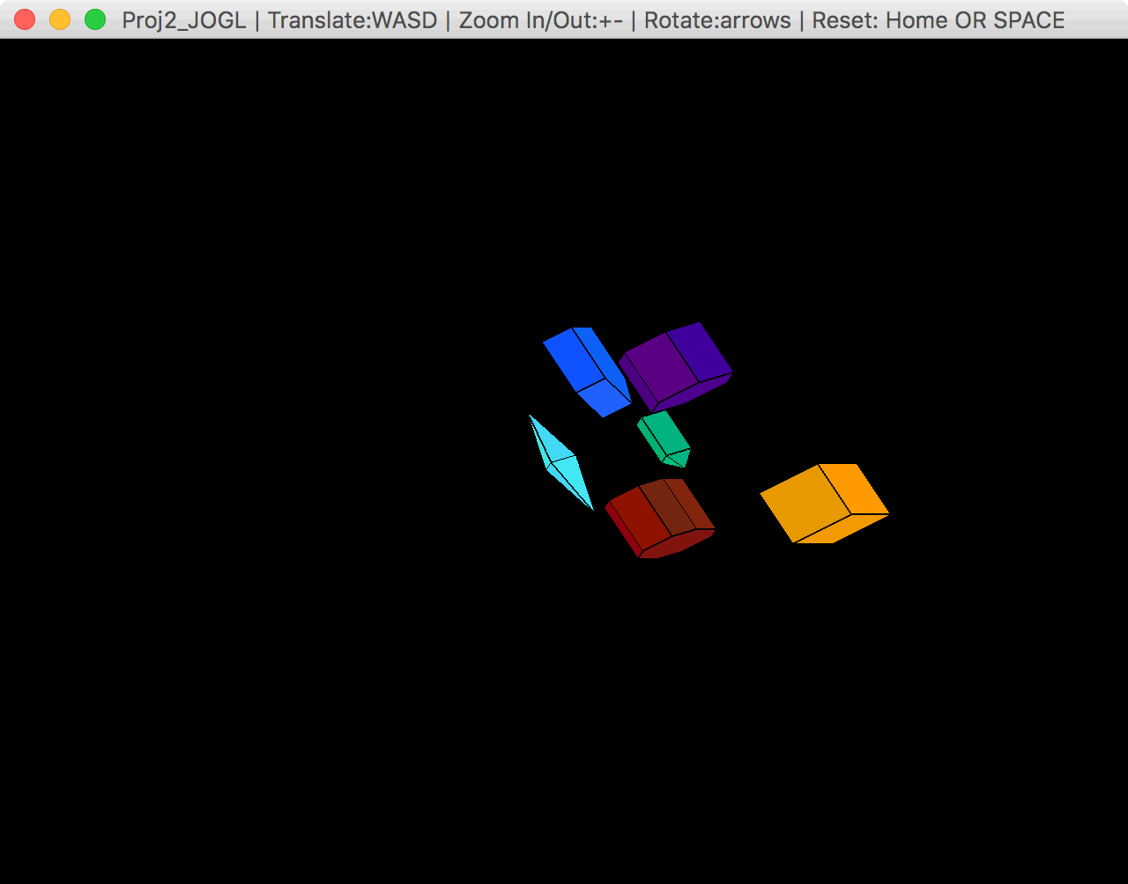

“W” button x2 that translates the objects in the y-axis +0.2 each time:

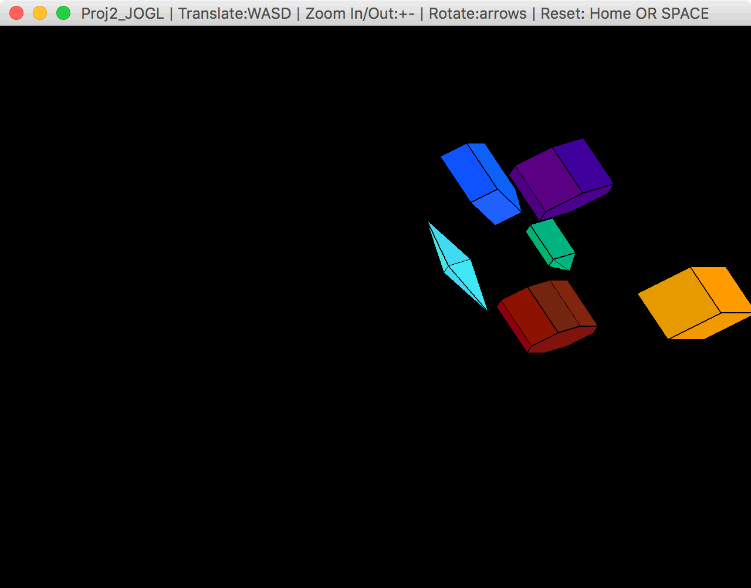

“S” button x2 that translates the objects in the y-axis -0.2 each time:

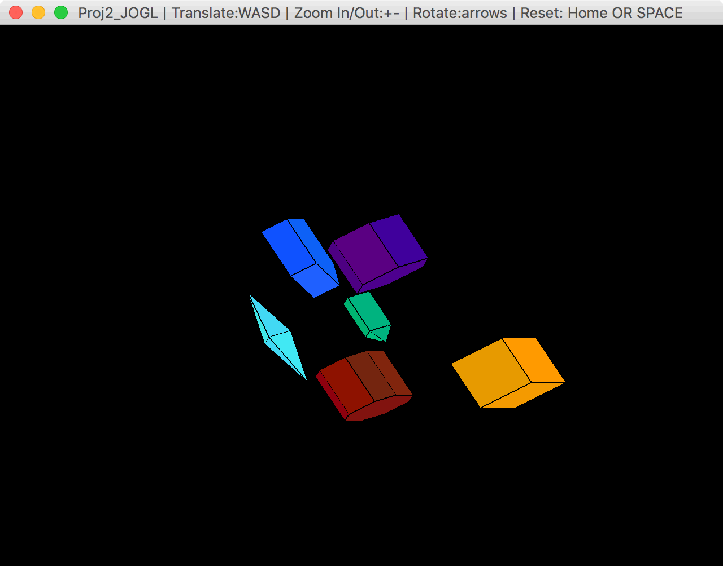

“A” button x2 that translates the objects in the x-axis -0.2 each time:

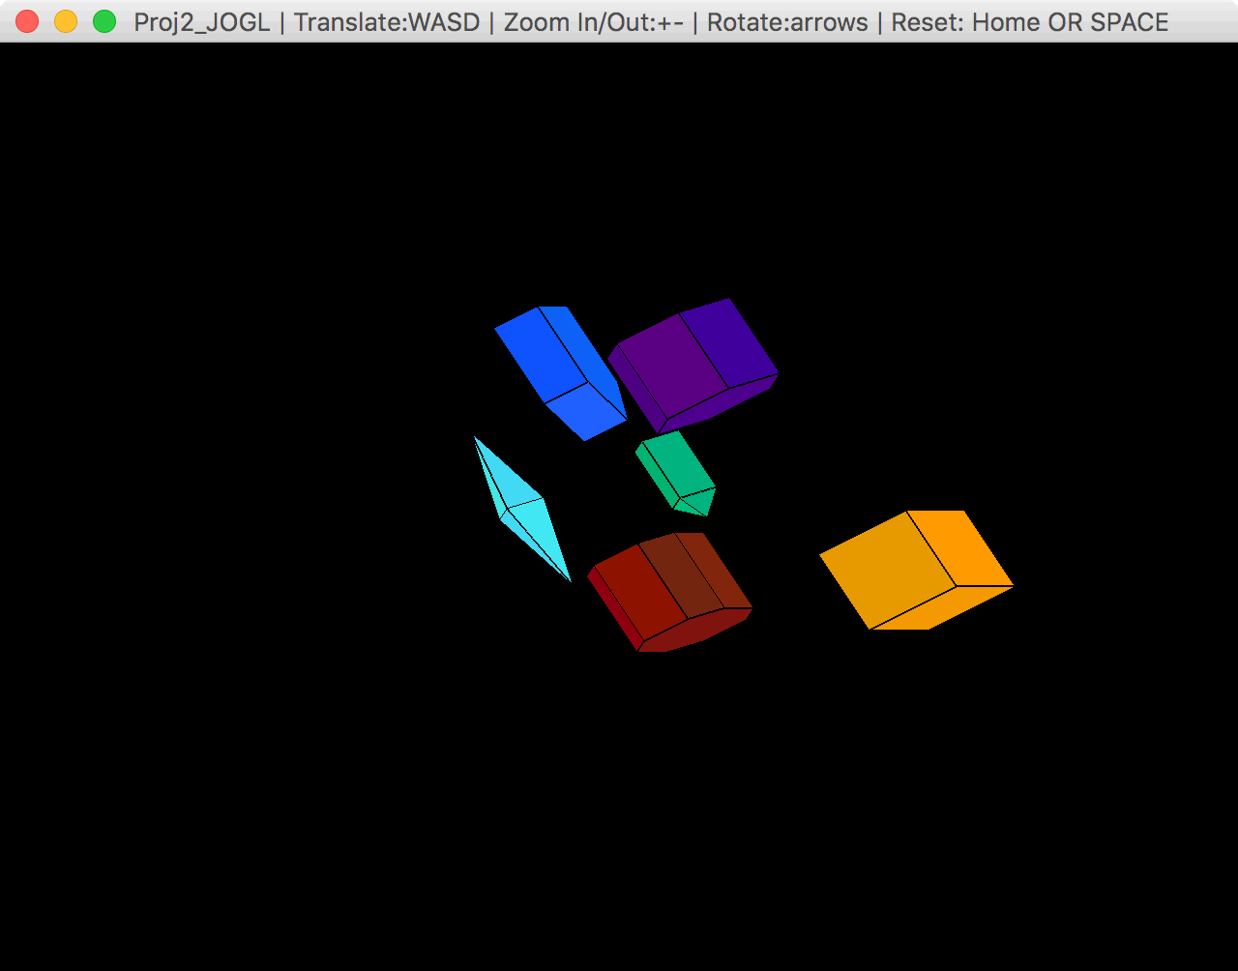

“D” button x2 that translates the objects in the x-axis +0.2 each time:

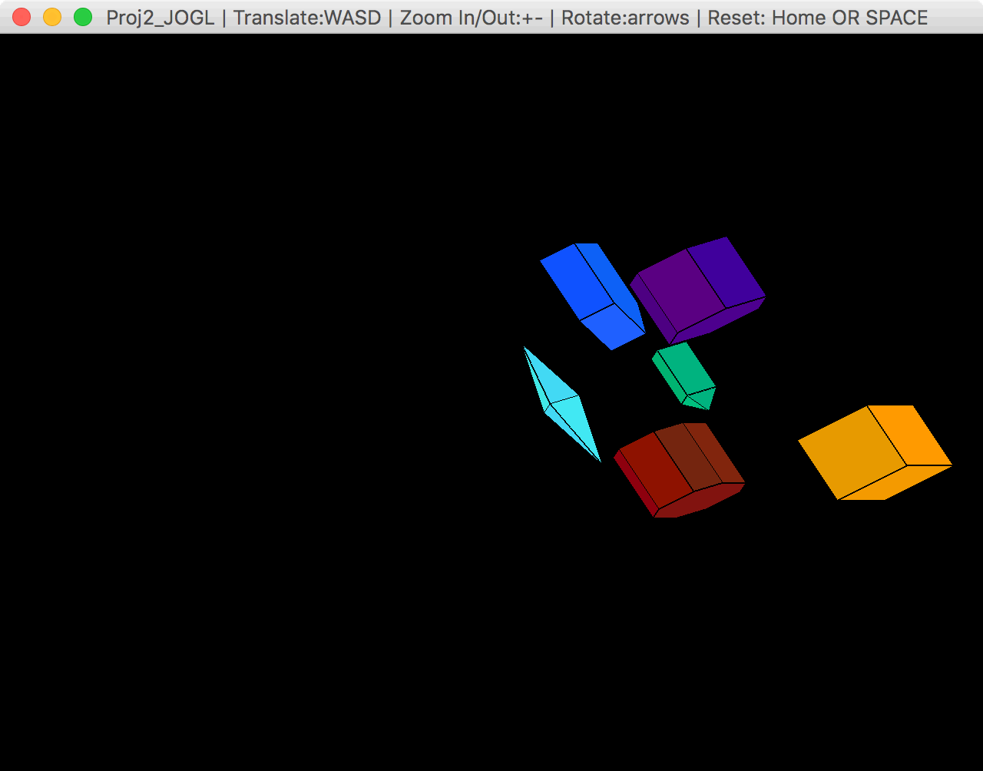

“HOME” or “SPACE” Button that resets the view back to default:

